pandas as pd
import matplotlib.pyplot as plt

# Load dataset
flight = pd.read_csv("C:/Users/USER/Downloads/R & Python/flight_data.csv")

# Random sample using student ID
flight_sample = flight.sample(n=10000, random_state=66)

## Q.1: What do coach ticket prices look like? What are the high and low values? What would be considered the average? Does $500 seem like a good price for a coach ticket?”
Solution
#Summary statistics
print(flight_sample['coach_price'].describe())

# Mean
mean_price = flight_sample['coach_price'].mean()
print("Average Coach Price:", mean_price)

# Histogram
plt.hist(flight_sample['coach_price'], bins=30)
plt.xlabel("Coach Ticket Price")
plt.ylabel("Frequency")
plt.title("Distribution of Coach Ticket Prices")
plt.show()
Output
count 10000.000000
mean 377.572120
std 67.287038
min 94.535000
25% 333.180000
50% 380.842500
75% 427.177500
max 580.850000
Name: coach_price, dtype: float64
Average Coach Price: 377.57212000000004
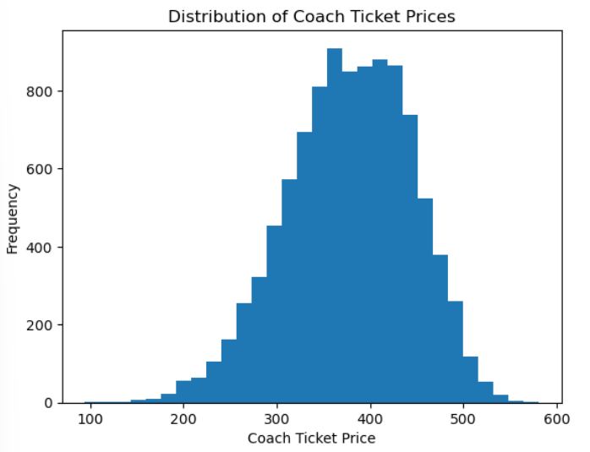

##Q2: What are the coach prices for flights that are 8 hours long? Does a $500 ticket seem more reasonable for these flights?
Solution
# 8-hour flights
flight_8hr = flight_sample[flight_sample['hours'] == 8]

# Summary statistics
print(flight_8hr['coach_price'].describe())
Output
count 212.000000
mean 438.763821
std 57.962725
min 242.600000
25% 405.296250
50% 446.252500
75% 478.943750
max 561.750000
Name: coach_price, dtype: float64

##Q3: What does the distribution of flight delays look like? Are there any outliers?

Solution
import matplotlib.pyplot as plt

# Histogram of delays
plt.hist(flight_sample['delay'], bins=40)
plt.xlabel("Delay Time")
plt.ylabel("Frequency")
plt.title("Distribution of Flight Delays")
plt.show()

# Summary statistics
print(flight_sample['delay'].describe())

Output
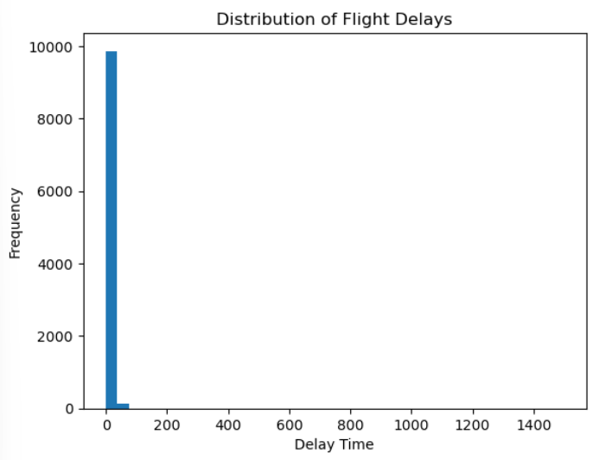
count 10000.000000
mean 13.139800
std 39.697635
min 0.000000
25% 9.000000
50% 10.000000
75% 13.000000
max 1497.000000
Name: delay, dtype: float64

##Q4: How are coach ticket prices related to flight distance (miles)?

Solution
import seaborn as sns
import matplotlib.pyplot as plt

# Scatter plot
sns.scatterplot(
x='miles',
y='coach_price',
data=flight_sample
)

plt.xlabel("Miles")
plt.ylabel("Coach Price")
plt.title("Coach Price vs Flight Distance")
plt.show()

# Correlation
print(flight_sample[['miles','coach_price']].corr())

Output
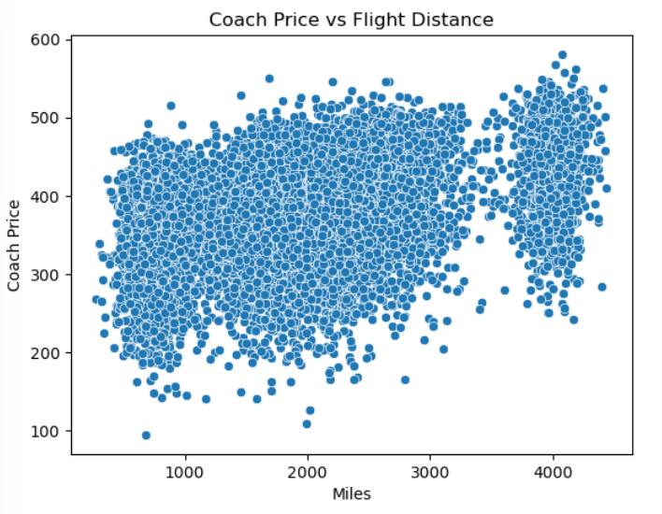
miles coach_price
miles 1.000000 0.372265
coach_price 0.372265 1.000000

##Q5: How are flight hours related to coach ticket prices?
Solution

import seaborn as sns
import matplotlib.pyplot as plt

# Scatter plot
sns.scatterplot(
x='hours',
y='coach_price',
data=flight_sample
)

plt.xlabel("Flight Hours")
plt.ylabel("Coach Price")
plt.title("Flight Hours vs Coach Price")
plt.show()

# Correlation
print(flight_sample[['hours','coach_price']].corr())

Output
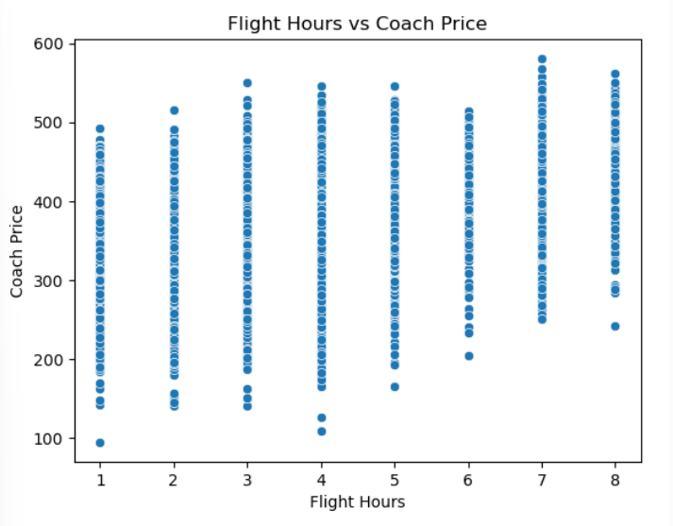
hours coach_price
hours 1.000000 0.366395
coach_price 0.366395 1.000000

##Q6: How are coach ticket prices related to first-class ticket prices?

Solution
import seaborn as sns
import matplotlib.pyplot as plt

# Scatter plot
sns.scatterplot(
x='coach_price',
y='firstclass_price',
data=flight_sample
)

plt.xlabel("Coach Price")
plt.ylabel("First Class Price")
plt.title("Coach vs First-Class Prices")
plt.show()

# Correlation
print(flight_sample[['coach_price',
'firstclass_price']].corr())

Output
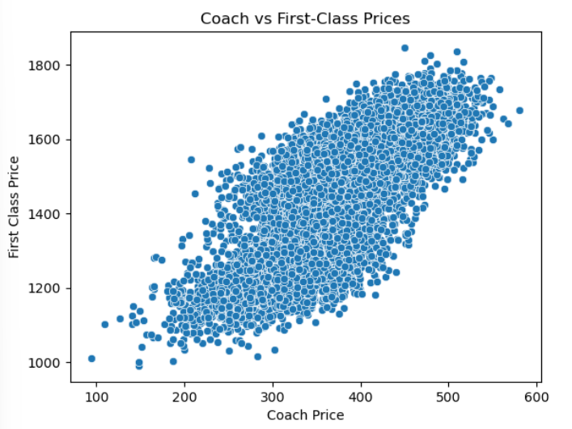
coach_price firstclass_price
coach_price 1.000000 0.757325
firstclass_price 0.757325 1.000000

##Q7: How do in-flight features affect coach ticket prices?
Solution
# Average coach prices by features
print(flight_sample.groupby(
'inflight_meal')['coach_price'].mean())

print(flight_sample.groupby(
'inflight_entertainment')['coach_price'].mean())

print(flight_sample.groupby(
'inflight_wifi')['coach_price'].mean())
Output
inflight_meal
No 371.829576
Yes 391.282637
Name: coach_price, dtype: float64
inflight_entertainment
No 322.052406
Yes 391.209997
Name: coach_price, dtype: float64
inflight_wifi
No 314.918785
Yes 384.310008
Name: coach_price, dtype: float64

##Q8: How do weekend flights compare to weekday flights in terms of ticket prices?

Solution
import pandas as pd
import seaborn as sns
import matplotlib.pyplot as plt

# Average ticket prices
weekend_price = flight_sample.groupby('weekend')[
['coach_price', 'firstclass_price']
].mean()

print(weekend_price)

# Bar plot
weekend_price.plot(kind='bar')

plt.title("Weekend vs Weekday Ticket Prices")
plt.ylabel("Average Price")
plt.xticks(rotation=0)
plt.show()

Output
coach_price firstclass_price
weekend
No 323.047448 1258.846526
Yes 406.088374 1559.762531
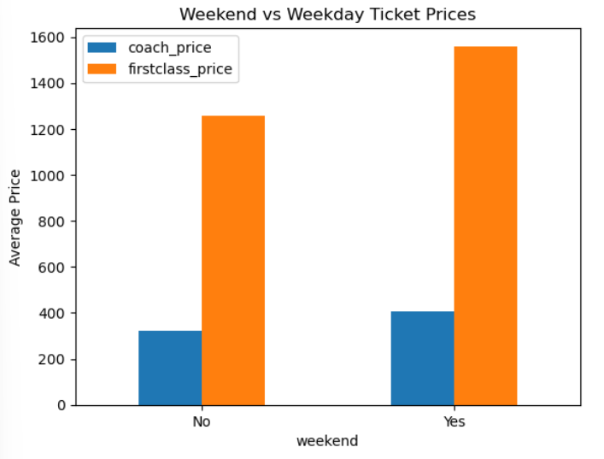

##Q9: How do redeye flights compare to non-redeye flights in terms of coach ticket prices?

Solution
import seaborn as sns
import matplotlib.pyplot as plt

# Average coach prices
redeye_price = flight_sample.groupby('redeye')[
'coach_price'
].mean()

print(redeye_price)

# Bar plot
redeye_price.plot(kind='bar')

plt.title("Redeye vs Non-Redeye Coach Prices")
plt.ylabel("Average Coach Price")
plt.xticks(rotation=0)
plt.show()

Output
redeye
No 380.715426
Yes 316.435143
Name: coach_price, dtype: float64

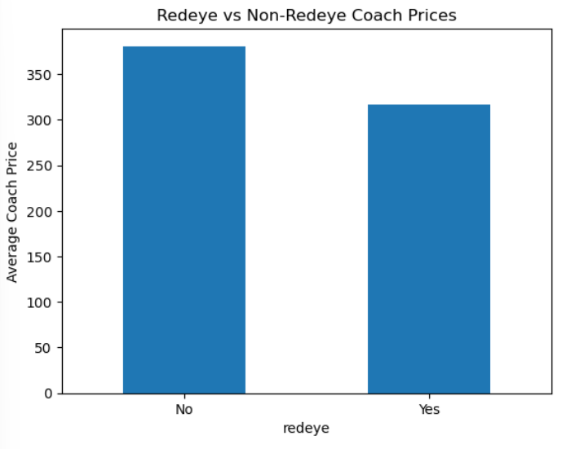

##Q10: Perform the analysis for appropriate variables

Solution
#(1)Summary

flight_sample.describe()

Output

Miles | passengers | delay | coach_price | firstclass_price | hours

count | 10000.000000 | 10000.000000 | 10000.000000 | 10000.000000 | 10000.000000 | 10000.000000
mean | 2011.737400 | 207.653500 | 13.139800 | 377.572120 | 1456.427975 | 3.635600
std | 955.070753 | 12.714905 | 39.697635 | 67.287038 | 162.780237 | 1.760092
min | 279.000000 | 143.000000 | 0.000000 | 94.535000 | 990.010000 | 1.000000
25% | 1320.000000 | 204.000000 | 9.000000 | 333.180000 | 1304.675000 | 2.000000
50% | 1982.500000 | 209.000000 | 10.000000 | 380.842500 | 1503.420000 | 4.000000
75% | 2475.000000 | 215.000000 | 13.000000 | 427.177500 | 1584.047500 | 4.000000
max | 4438.000000 | 236.000000 | 1497.000000 | 580.850000 | 1846.780000 | 8.000000

#10(2) Visualization
import matplotlib.pyplot as plt

# Histogram
plt.hist(flight_sample['coach_price'], bins=30)
plt.title("Coach Price Distribution")
plt.show()

# Boxplot
plt.boxplot(flight_sample['coach_price'])
plt.title("Coach Price Boxplot")
plt.show()

# Bar chart
flight_sample['weekend'].value_counts().plot(kind='bar')
plt.title("Weekend Flights")
plt.show()
Output
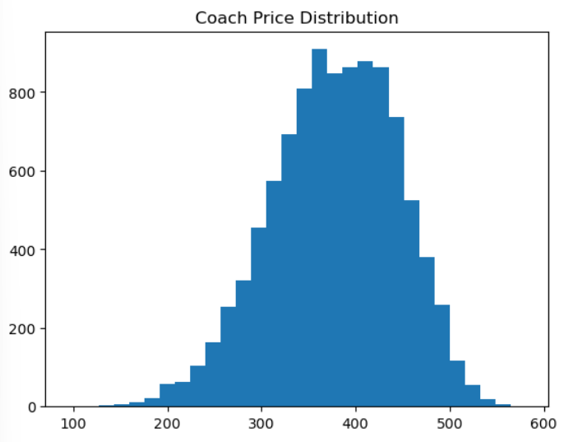

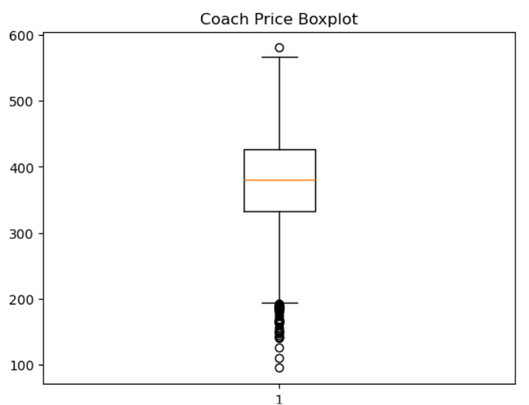
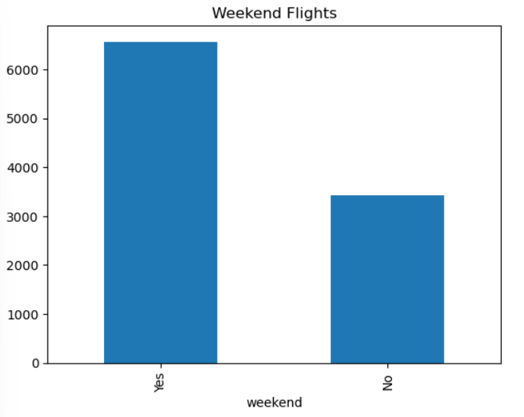

##10(c) Hypothesis Testing (t-test)
from scipy import stats

weekend_yes = flight_sample[
flight_sample['weekend']=="Yes"
]['coach_price']

weekend_no = flight_sample[
flight_sample['weekend']=="No"
]['coach_price']
stats.ttest_ind(weekend_yes, weekend_no)
output
TtestResult(statistic=np.float64(72.3196681400005), pvalue=np.float64(0.0), df=np.float64(9998.0))

##10(d) Correlation Analysis

flight_sample[
['coach_price',
'miles',
'hours',
'delay']
].corr()

Output
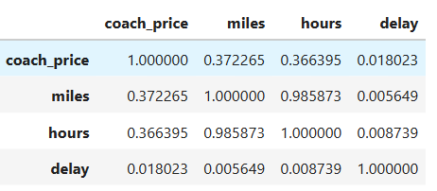

##10(e) Regression Analysis

from sklearn.linear_model import LinearRegression

X = flight_sample[
['miles','hours','delay']
]

y = flight_sample['coach_price']

model = LinearRegression()
model.fit(X,y)

print(model.coef_)

Output
[ 0.02785972 -0.90216435 0.02711225]

##10(f) Logistic Regression
from sklearn.linear_model import LogisticRegression

flight_sample['redeye_binary'] = (
flight_sample['redeye']=="Yes"
).astype(int)

X = flight_sample[
['hours','coach_price']
]

y = flight_sample['redeye_binary']

log_model = LogisticRegression()
log_model.fit(X,y)

print(log_model.score(X,y))
Output
0.9508

from sklearn.linear_model import LinearRegression

X = flight_sample[
['miles',
'hours',
'delay']
]

y = flight_sample['coach_price']

model = LinearRegression()

model.fit(X, y)

print(model.coef_)
print(model.intercept_)

Output
[ 0.02785972 -0.90216435 0.02711225]
324.44933798732814
impor

